**Preliminary 25 examination questions** (*Data structure and Algorithms, Fall 2024*)

1. Name the last element in array of size n:

2. Name the data structures following FIFO principle.

3. Function call is better done with which data structure?

4. What data structure suitable for file management?

5. What data structure suitable for task management?

6. What data structure is suitable for storing pack of banknotes?

7. How do we store class in header file? Do we separate class signature from implementation?

8. Name the data structures following LIFO principle:

9. Which search algorithm(s) require the elements to be sorted?

10. Which search algorithm(s) doesn’t require the elements to be sorted?

11. What are the common functions of stack data structure?

12. What are the common functions of queue data structure?

13. What are the common functions of linked list data structure?

14. How different is circular queue from common queue data structure?

15. Output of the following code snippet:

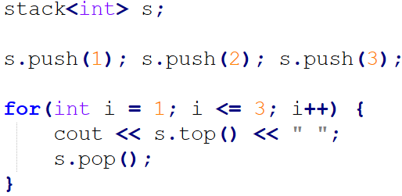

16. Output of the following code snippet:

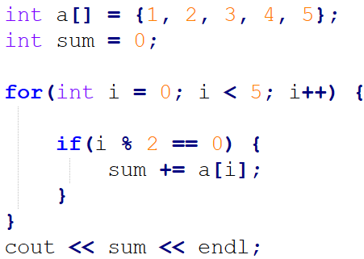

17. Write how else part of pop function in stack using array:

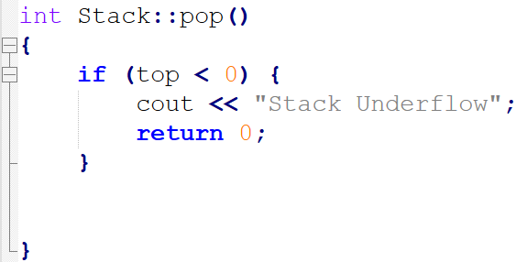

18. Below is source code and write the source code to add numbers ***4, 5, 6*** to stack in ***between the lines*** stack created and first item popped from it.

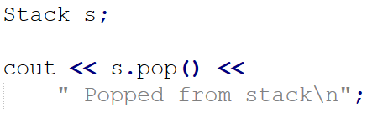

19. What are the syntax errors from the following source code:

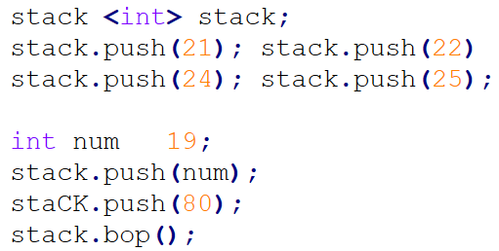

20. Using STL stack library write a source code that creates stack, adds few numbers and prints first item on stack on console. Please, include iostream and other necessary source in your written answer:

21. Using STL queue library write a source code that creates queue, adds few numbers and prints front and rear item on queue on console. Please, include iostream and other necessary source in your written answer:

22. What is an array, and what index out of bound exception means?

23. Can array be resized in runtime?

24. How linear search and binary search different from one another?

25. Which sorting algorithm is more efficient, insertion sort or selection sort? Explain your arguments.

~ ~ END OF DOCUMENT ~~